HEALTH CARE CHATBOT SYSTEM

# Akash Goel

Computer Science

KIET Group of Institutions Ghaziabad, India

Akash.goel@kiet.edu

# Satyam

Computer Science

KIET Group of Institutions Ghaziabad, India[Satyam.1923cs1200@kiet.edu](mailto:priyanshi.1923co1069@kiet.edu)

# Shubham Sharma

Computer Science

KIET Group of Institutions Ghaziabad, India [Shubham.1923cs1206@kiet.edu](mailto:rishabh.1923co1033@kiet.edu)

*Abstract*— **In this era of Artificial Intelligence, the machine are becoming capable to work like the humans .For Living a good life in this world the most important thing is Health care and the difficult part is to get the consultant of the Doctors. Every person is not able to go to the doctors from every health problem .The goal of our team is create or build a Health care chatbot in AI that help us to find the problem of the person and deliver basic information before consulting a doctor but only for minor problems.By using a medical chatbot, this will minimise healthcare cost and it will increase the medical information. The chatbots are computational programs that communicate with users by using the AI and ML.The chatbot system gets the query from the database which is asked by the user and make the decision based on that and display the answers.**

***Keywords*— Healthcare , Chatbot , Artificial Intelligence**

1. INTRODUCTION

Information is provided by computers, and they also entertain and provide the information in so many ways. The chatbots are computational programs that are designed for the communication in the intelligent way in text and the focus of that research paper is purely on text.

The chatbot systems are capable to learn by themselves and they get more experience with the help by communicate with more people and from some online resource available on the internet .Since information is pre-stored, this application is extremely fundamental. The system is using a chatbot to respond to user questions using the inquiry and response protocol. This system is designed to save users' time and money on healthcare because they can't always visit the clinics of the doctors .

Based on the problems of the user , the answer is provided. The sentences and responses to those sentences are where the important keywords are found.If a match or significant result is found, the response will be provided, and related responses will be displayed.Users won't waste much time consulting a doctor because they can ask any questions directly here about healthcare for some Small Healthcare problems. A relational database management system stores the chat pattern's input sentence (RDBMS). The chatbot would sync the user's question's input sentence with the knowledge base. Every inquiry is checked against the chatbot's knowledge base.

If a person has a specific disease, the chatbot can determine what kind of disease they have by asking them a few questions and receiving their responses. The chatbot's purpose is to provide support to people who are having body problems or illnesses (diseases) by suggesting medications tailored to their problems. After that, if a person wants to know about the precautions and remedies that he or she should take, the chatbot can also provide that information. We use our hardware boot as a server for client using programming to give them access at any time and on any place.

1. PROPOSED METHODOLOGY

## System Overview

Chatbots, which use machine learning to comprehend natural language, are powered by artificial intelligence. The main objective of the paper is to provide readers with fundamental health knowledge.

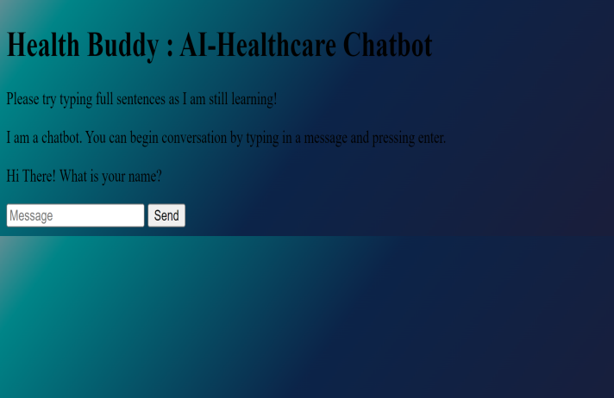

Fig.1:Interface of AI Healthcare Chatbot

In this Health care chatbot system , the user got the details

about the minor Health care problems and they can got some remedies and advice that will be provided by the Health care chatbot.Virtual assistants can assist patients and medical professionals with a variety of tasks related to medicine.

The user do the conversation with the bot that is controlled by some rules or AI rather than a real person. In other sectors, like retail, chatbots are already widely used to support, speed up, and improve processes. Now, the technology is gaining popularity in the healthcare sector.

Virtual assistant bots, also known as chatbots, are one of the new technologies that will continue to impact our daily lives as the demand for machine learning and AI increases.

The market's demand is continuously rising as we move toward digitalization, day by day. The main reasons for the need for medical chatbots in the medical industry are India's growing population and the scarcity of doctors to meet the needs of that population.

## Working

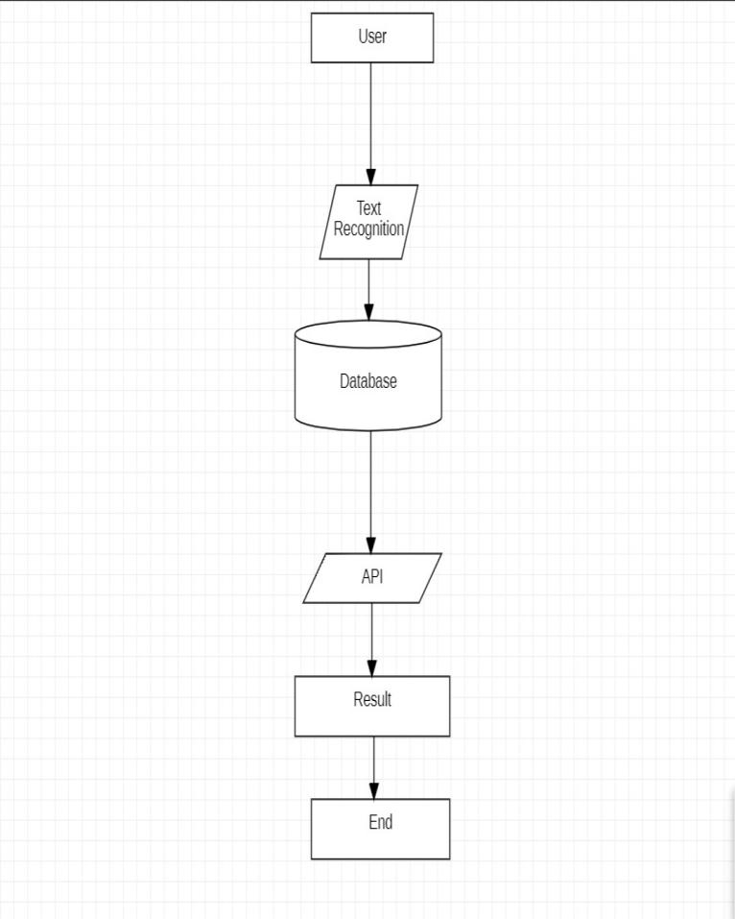

Fig.2: Working of AI Healthcare Chatbot

* + 1. **Fetch Input**

The first step of the working of the chatbot is to fetch the input and the query from the users in the foam of text and then process it to the next step as we can see in the flow diagram of the working of the chatbot.

## Process of Data

As can be seen in the chatbot's flowchart, in this step the chatbot will retrieve the data from the database and compare the keywords with the data. The output of the questions are stored in the database of the Chatbot .

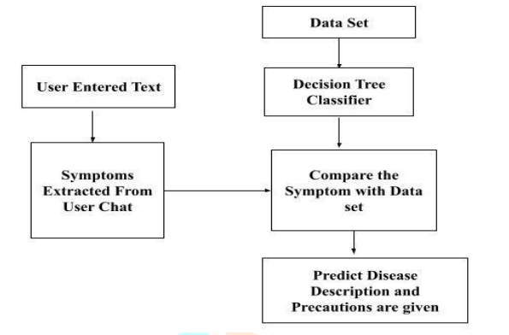

Fig.3: Working of fetching output

The chatbot in the starting requests the user's name, one primary ailment they are experiencing, and how long they have been experiencing that symptom. The chatbot will next ask the user what exact symptom they are experiencing. Type 0 for a high temperature, for instance, or type 1 for a low fever The user must respond "yes" or "no" to a series of questions the bot will ask after that regarding symptoms.

On the basis of the characteristics of the provided data collection, judgments are made or tests are run.

The algorithm poses a series of questions to the user and then determines the appropriate response. It foretells the sickness and, based on that, recommends the required safeguards.

## Output of Query

In this step, the chatbot responds to the user's query based on their input symptoms and displays the results so that the user can treat themselves or appoint a consultant in addition to a doctor or they can take the suggestion from the chatbot.

The technologies which used to create this chatbot are Flask, chatterbot , HTML, CSS and JS .

Flask is an open source web framework. It provides many web developing tools to develop an website or an app.

A Python have package which is used for creating the chatbot is known as chatterbot as we know that it was created to develop conversational software.

Untaught ChatterBot instances lack any past communication abilities. Every time a user writes a statement, the library records both the text that entered by the user and the text that the statement was in response to. As ChatterBot gathers additional data, both the number of responses it can offer and the accuracy of each one in relation to the input statement increase.

The method the computer uses to choose the response that most closely matches the input is to first seek for the known statement that most closely matches the input, and then choose one of the known replies to that statement from the list.

A Python library that is called as ChatterBot makes it very simple to create automatic answers based on the user input. ChatterBot provides many types of responses and answers using a variety of ML algorithms. Because of this, creating chatbots and user conversations is simple.

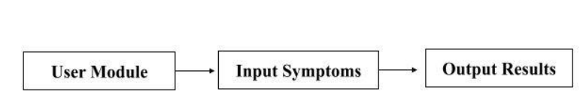

Fig.4 : User Module

1. LITERATURE REVIEW

In this, research paper are based on classify very type of emotions using AI techniques. The study use many ML algorithms , deep learning, and the most important NNN to train emotions classification models from a large amount of labelled data. The use of Natural Language Processing and Natural-language generation to understand user dialogues is crucial in counselling. The multi-modal approach to emotion recognition is used in this instance. They have gathered corpora to learn the semantics of words and represent them as vectors using word vectors, as well as lexical knowledge of synonyms.[1]

In this research paper, the voice recognition chatbot are created.When a question is not understood by thre bot .Information processing and data recognition from server response. Here, a SOAP-based black box server is being used. It is possible to develop the intelligence by using many expert system.[2]

The main aim of this chatbot is to develop or create the comm. Between the machines and the human beings. In this , the system keep the data from the DBMS it needs to recognise the sentence and choose how to respond to all the questions. User input receive a bigram similarity for input of the sentences. RDBMS is where the chatbot's database is kept.[3]

The chatbot's response pattern is saved and the sentence order is recognised using pattern comparison. Here, the author explains how the chatbot's operating system, software,programs , DBMS, and method for storing input and output results that implemented. Here, the input is obtained using by the text function, additional some words is removed using the trim function, and a response is chosen at random from the database using the random function. The chatbot serves a purely amusing function.[4]

In this case, the words from the sentences are extracted using the n-gram technique. Here, Moro phonemes and phonemes are used as the determining parameters and these parameters gives the result. The probability of the closest match is calculated. An expertsystem is used to redirect the final expression.[5]

The chatbot created here for the Android app's healthcare features. Using Google API, the user sends a text or voice message. The user in this case receives only pertinent chatbot responses. The dataset is classified using the SVM algorithm. Here, unneeded words like suffixes and prefixes are eliminated using the Porter algorithm.[6]

The content of the various web-served documents is examined with many of the machine learning algorithm that make that website very helpful for the health care sector and for many medical and health based companies .[7]

In this Research the chatbot have been designed made for service that also provides public health services. and cosine similarity. The question and answer are created and stored in the knowledge base. The application uses many methods to quickly answer questions by clearly displaying the keyword that was extracted from the question.[8]

Authors have proposed a framework that communicates with Chatbots using AIML and the R programming language. This study's goal is to give students a more interactive way to connect with the university system. The developer have designed a type of model that is better for the Information and the Education purposes.[9]

1. **CONCLUSION**

At that time the most used AI technology is chatbot that interact with the user and provide the solution in a very proper way. This chatbot is designed to provide the accurate response in very less period of time that will helpful to the user .

Each keyword are given in the fewer weight into a order for getting the right responses of the user problems. The web interface was created with users' input queries in mind. By ensuring user protection, character integrity, and retrieving answers in line with the questions, the application is strengthened in terms of security and effectiveness and new modules will be added to the chatbot with respect to time.

The recommended method is very successful, inexpensive, straightforward, and it is an quick way to let patients connect with the chatbot in a way that supports and helps them correctly take care of their health and their probelms. Users can share their symptoms and they can receive the advice from the chatbot by using the chatbot.The system is readily accessible at any time and from any location. The chatbot is available round-the-clock.

1. **REFRENCES**
2. K. Oh, D. Lee, B. Ko and H. Choi, "A Chatbot for Psychiatric Counseling in Mental Healthcare Service Based on Emotional Dialogue Analysis and Sentence Generation," 2017 18th IEEE International Conference on Mobile DataManagement (MDM), Daejeon, 2017, pp. 371-375. doi: 10.1109/MDM.2017.64
3. Du Preez, S.J. & Lall, Manoj & Sinha, S. (2009). An intelligent webbased voice chat bot. 386391.10.1109/EURCON.2009.5167660
4. Bayu Setiaji, Ferry Wahyu Wibowo, "Chatbot Using a Knowledge in Database: Human-to- Machine Conversation Modeling", Intelligent Systems Modelling and Simulation (ISMS) 2016 7th International Conference on, pp. 72-77, 2016.

[4].Dahiya, Menal. (2017). A Tool of Conversation: Chatbot.

INTERNATIONAL JOURNAL OF COMPUTER SCIENCES AND ENGINEERING. 5. 158-161.2017.

1. C.P. Shabariram, V. Srinath, C.S. Indhuja, Vidhya (2017). Ratatta: Chatbot Application Using Expert System, International Journal of Advanced Research in Computer Science and Software Engineering,2017
2. Mrs Rashmi Dharwadkar1, Dr.Mrs. Neeta A. Deshpande, A Medical ChatBot, International Journal of Computer Trends and Technology (IJCTT) – Volume 60 Issue 1- June 2018
3. Farheen Naaz, Farheen Siddiqui, modified n-gram based model for identifying and filtering near-duplicate documents detection, International Journal of Advanced Computational Engineering and Networking, ISSN: 2320- 2106, Volume-5, Issue-10, Oct.-2017
4. N-gram Accuracy Analysis in the Method of Chatbot Response, International Journal of Engineering & Technology. (2018)
5. Shukla, V.K, Verma, A, "Enhancing LMS Experience through AIML Base and Retrieval Base Chatbot using R Language", 2019 International Conference on Automation, Computational and Technology Management (ICACTM)
6. Hiba Hussain1, Komal Aswani2, Mahima Gupta3, Dr. G.T.Thampi4,”Implementation of Disease Prediction Chatbot and Report Analyzer using the Concepts of NLP, Machine Learning and OCR,”IRJET,Apr 2020.